Access Modifiers in Java
Access modifiers in Java are keywords that define where a class, method, or variable can be accessed. These modifiers help to protect data and control access to code. In this chapter, we will learn about the access modifiers and how they control the visibility of classes, methods, and variables.
- public
- private
- protected
- default
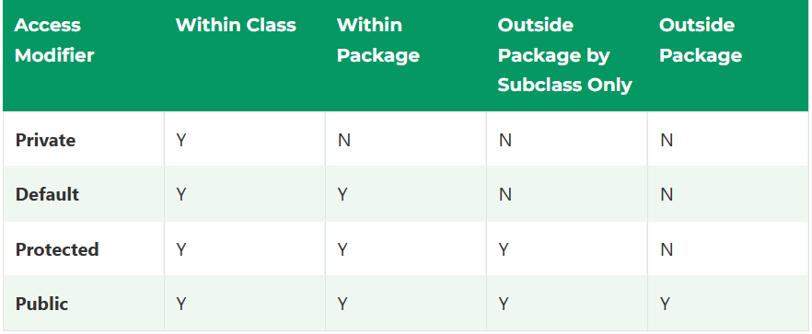

1. public Access Modifier
The access level of a public modifier is everywhere. It can be accessed from within the class, outside the class, within the package and outside the package. It has the widest scope among all other modifiers. 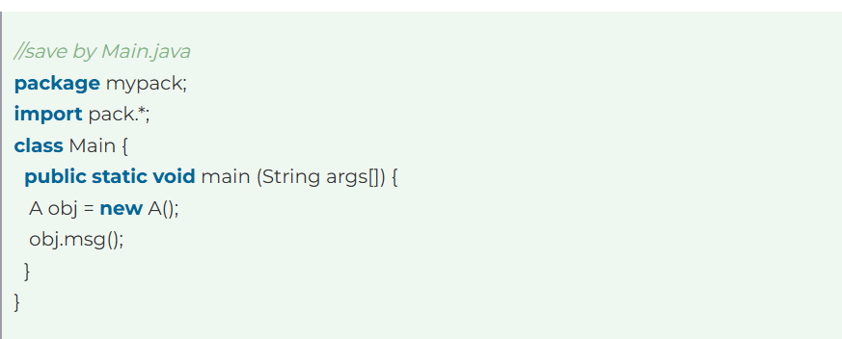

2. private Access Modifier
The access level of a private modifier is only within the class. It cannot be accessed from outside the class.
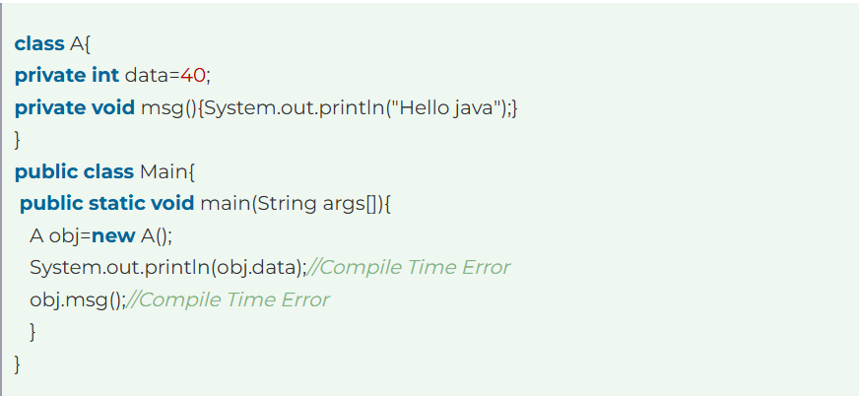

3. protected Access Modifier
The protected access modifier is accessible within the package and outside the package, but through inheritance only. The protected access modifier can be applied to the data member, method and constructor. It cannot be applied to the class. It provides more accessibility than the default modifier.

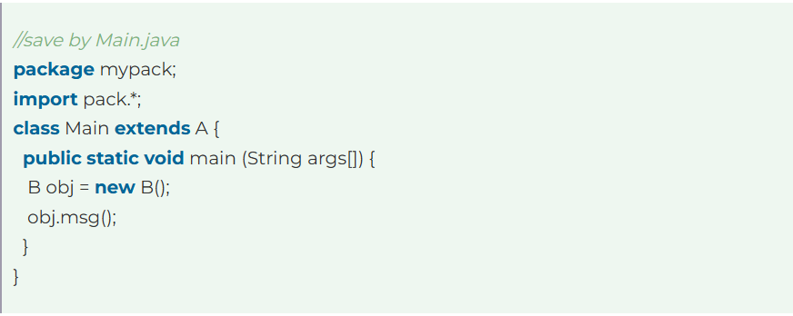4. Default Access Modifier
When we do not specify any specifier, the default access specifier is prefixed by default. The default modifier is accessible within a package only. It cannot be accessed from outside the package. It provides more accessibility than private. But it is more restrictive than protected and public.
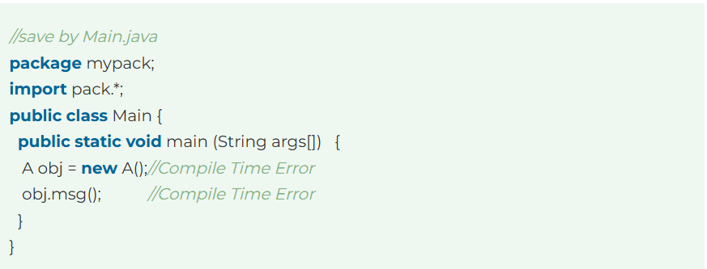
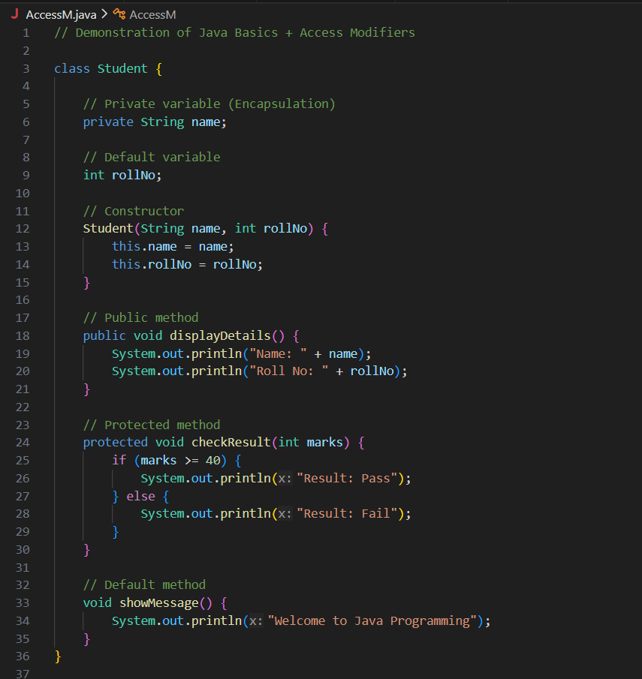
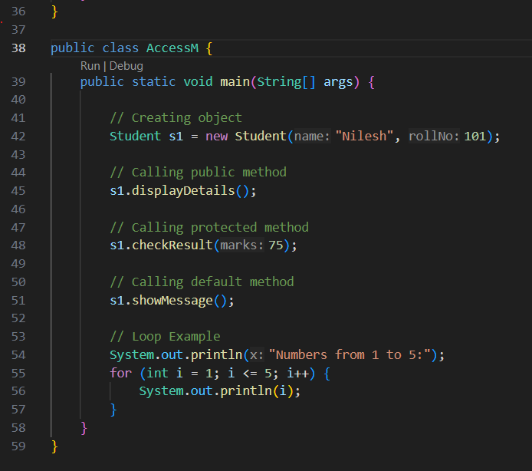

Name:-Nilesh Chavan
PRN:-202401110017
Name:- Harshad Dhokare
PRN:-202401110024

